The Scientific Definition of Work

What It Means to Do Work

The Scientific Definition of Work differs in some ways from its everyday meaning. Certain things we think of as hard work, such as writing an exam or carrying a heavy load, are not work as defined in physics. The scientific definition of work reveals its relationship to energy - wherever work is done, energy is transferred.

For work to be done in the scientific sense, a force must be exerted, and there must be displacement in the direction of force, or a force has to be in the direction of displacement, or at least the force has a component in the direction of displacement.

What is Work?

The work done on an object or a system by a constant force is the product of the component of the force in the direction of motion times the distance through which the force acts.
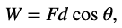
Where W is work, F is the magnitude of the force exerted, d is the magnitude of the displacement, and θ is the angle between the force vector F and the displacement vector d.

The SI unit for work is Joules. Work is a scalar: it has no direction, but only magnitude.

Example 1. Determine Positive, negative, or zero work done by force F in the pictures below:

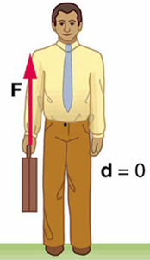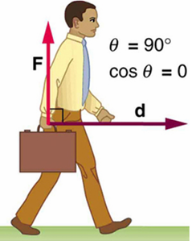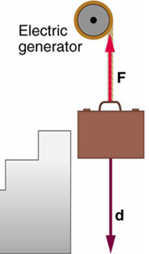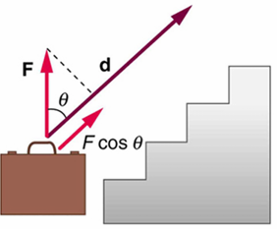
- (b) (c) (d)

 θ is the angle between the force vector F and the displacement vector d.
If $0^{o}$ <= θ < ${90}^{o}$ Cosθ > 0, Work done is positive,
If ${90}^{o}$ < θ <= ${180}^{o}$ Cosθ <0, Work done is negative,
If θ = ${90}^{o}$ , Cosθ = 0, Work done is zero.

Since Cos$0^{o}$ = 1, Cos${90}^{o}$ = 0, Cos${180}^{o}$ = - 1

Example 2. How much work is done by the person if he exerts a constant force of 75.0 N at an angle of 35 degrees below the horizontal and pushes the mower 25.0 meters on the level ground?
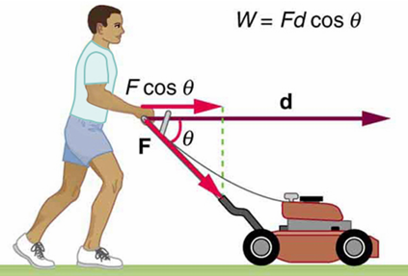

Practice Problems for Work:

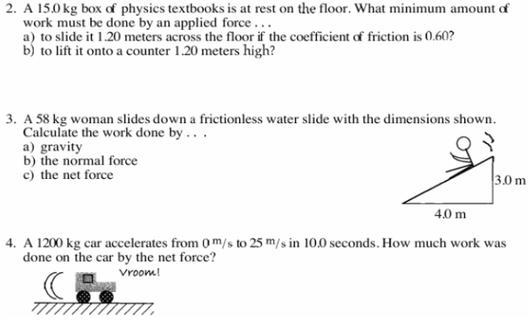

Kinetic Energy

Kinetic Energy is a form of energy associated with the motion of a particle, a single object, or a system of objects moving together. In equation, the kinetic energy KE of an object with mass m and speed v is:
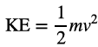

The Work-Energy Theorem

The net work done on a system equals the change of the kinetic energy of the system:
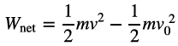

Example 3. Suppose a 30.0 kg package on the roller belt conveyor system is moving at 0.50m/s. (a) What is its kinetic energy? Suppose you push on the package with a constant force of 120 N through a distance of 0.80 m, and the opposing friction is 5.0 N (b) What is the net work done on the package? (c) What is the final speed of the package?

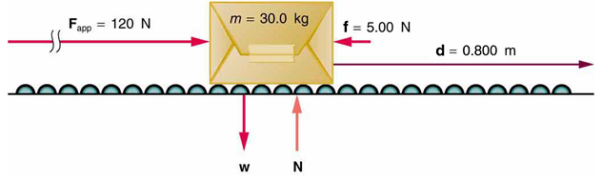

Practice Problems for Work-Energy Th:


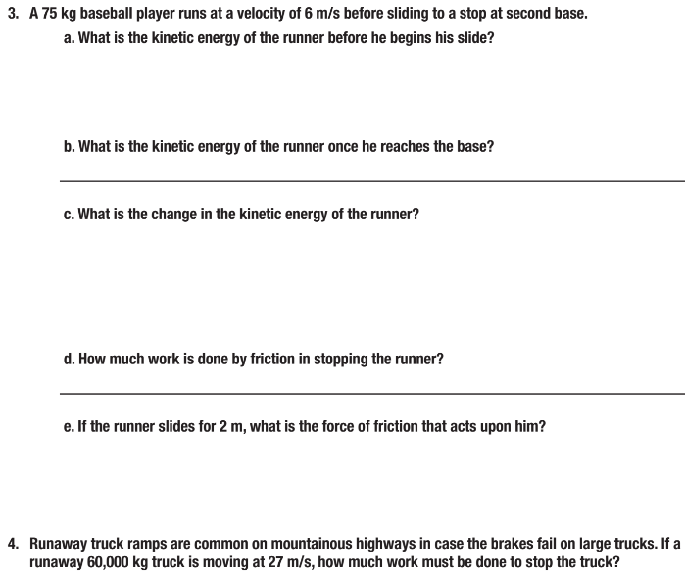

Pulley Systems and Tension:
1.

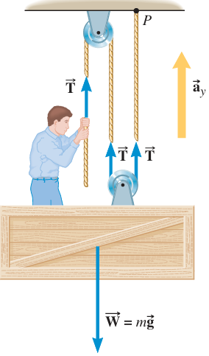Figure 4.36 (a) 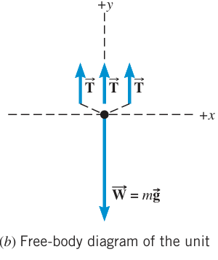

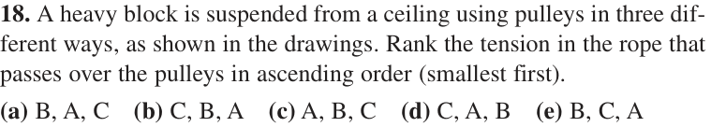
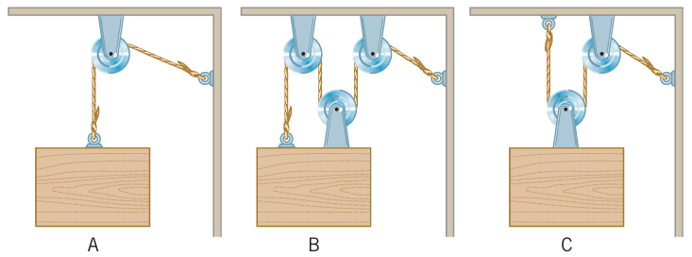

Mechanical Advantages of Pulley Systems
Introduction: Pulleys can change the direction of a force or reduce the force needed to move an object.
Question: Can a Pulley system even reduce the amount of work needed to lift an object?
Task: In this investigation, we will test three different pulley setups and determine the mechanical advantage and efficiency of each.
Materials: Stand, three pulleys, 1 single and 2 double. One large mass between 0.5 to 1 kg, string and scissors, force gauges (0-5N and 0-10N), metersticks.
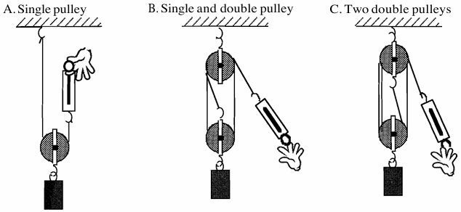
Procedure:

1.
